Department of Computer Science and Engineering (Data Science)
CSDS-A | Batch A17 (CSE - Data Science, Section A)
CropSight: Smart Crop Delivery with AI-Based Price and Quality Intelligence
(CropSight)
S.No. | Student name | Roll / hall ticket no.
1 | G.PRANAVI | 23K91A6765
2 | G.SIRI CHANDANA | 23K91A6763
3 | A.NIKHIL | 23K91A6715
4 | G.VISHNU VARDHAN | 23K91A6754
Under the guidance of: K. Mounika, [DESIGNATION]
BLOCK DIAGRAMS
This document collects every design diagram of CropSight. Each diagram was drawn from the real code, database models and routes and is followed by a paragraph that explains it. The diagrams were generated by scripts/make_diagrams.py with matplotlib.
Table 1: Diagrams in this document
No. | Diagram | Shows
1 | System architecture | Browser, React web app, FastAPI routers and services, model files, SQLite, uploads, simulated sensor source
2 | High-level workflow | Ten steps from upload to delivery
3 | DFD level 0 | Context: CropSight and its external entities
4 | DFD level 1 | Seven processes and six data stores
5 | DFD level 2 | Expansion of the crop-grading process
6 | Use-case diagram | Actors and their use cases
7 | Sequence diagram | Grading a photograph, forecasting, ordering and shipping
8 | ER diagram | Nine database tables
9 | UML class diagram | Domain entities, engines and routers
10 | Algorithm flowchart | Control flow of grading and of delivery scoring

1 System Architecture
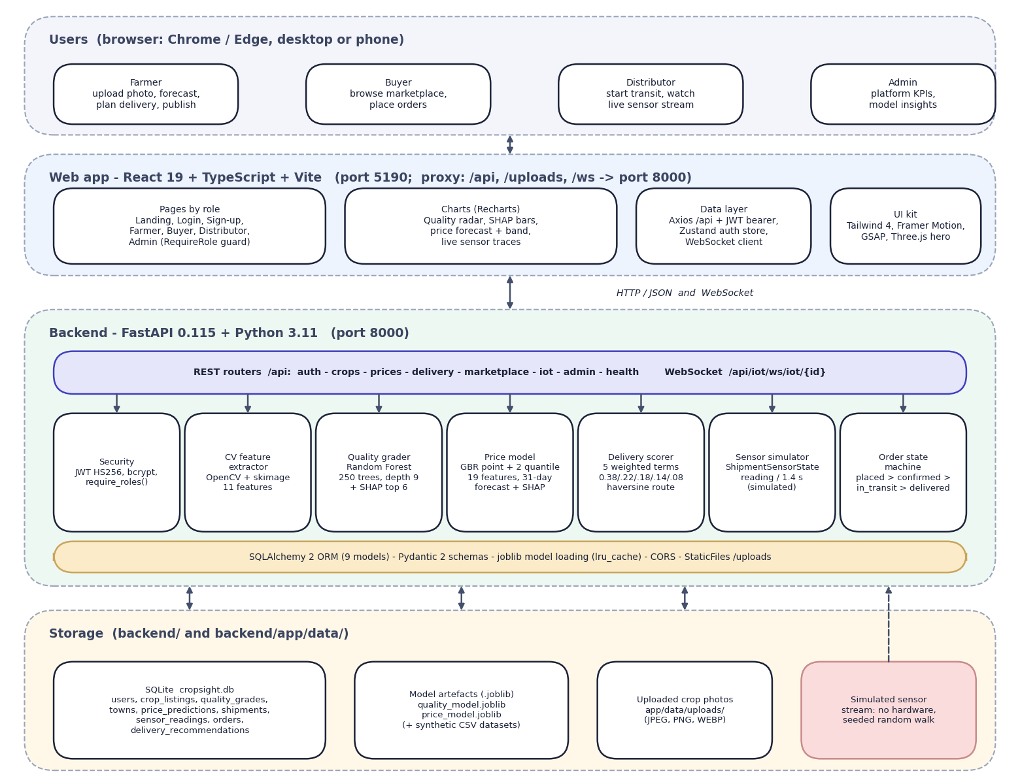
Fig. 1: System architecture of CropSight
The diagram shows five layers. At the top are the four kinds of user, each working in a browser: the farmer uploads a photo, forecasts the price, plans delivery and publishes; the buyer browses the marketplace and places orders; the distributor starts transit and watches the live sensor stream; the admin sees platform figures and model insights. Below them is the React 19 web application served by Vite on port 5190, which proxies /api, /uploads and /ws to the backend. It has role-based pages, Recharts charts (quality radar, SHAP bars, price forecast with its band, live sensor traces), a data layer (Axios with the bearer token, a Zustand authentication store and the WebSocket client) and the user-interface kit.
The backend is a FastAPI application on port 8000. Its REST routers (auth, crops, prices, delivery, marketplace, iot, admin and health) and one WebSocket route call seven building blocks: security (JWT and bcrypt, require_roles), the image feature extractor, the quality grader (Random Forest with SHAP), the price model (gradient boosting with two quantile models, a 31-day forecast and SHAP), the delivery scorer, the sensor simulator and the order state machine. SQLAlchemy maps nine models to SQLite; the joblib model files are loaded once and cached. Storage is local: the cropsight.db file, the two model artefacts with their synthetic CSV datasets, and the uploaded photos. The shaded box marks the sensor source as simulated: no hardware is connected.

2 High-Level Workflow
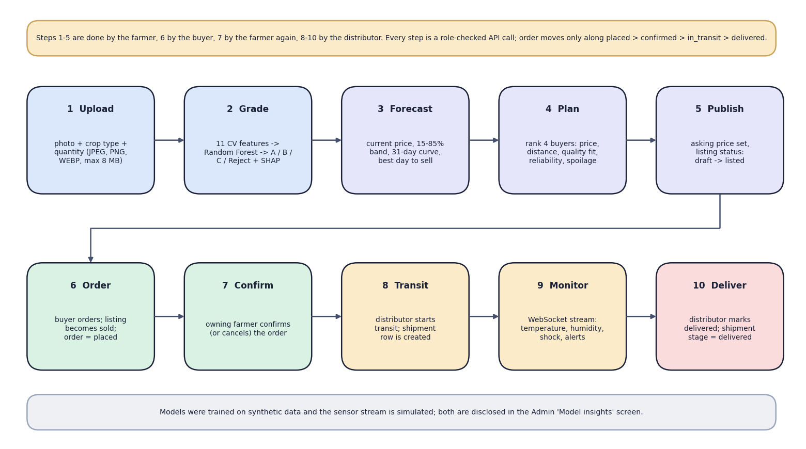
Fig. 2: High-level workflow
The ten steps follow one crop from the field to delivery. Steps 1 to 5 belong to the farmer: upload the photo with crop type and quantity, grade it (11 features, Random Forest, SHAP), forecast the price, plan delivery and publish the listing. Step 6 is the buyer's order, which marks the listing sold. Step 7 is the owning farmer's confirmation. Steps 8 to 10 belong to the distributor: start transit, which creates a shipment; watch the live sensor stream; and mark the order delivered. Every step is a role-checked API call and the order moves only along placed, confirmed, in transit and delivered. The note at the bottom states that the models were trained on synthetic data and the sensor stream is simulated.

3 Data-Flow Diagram: Level 0
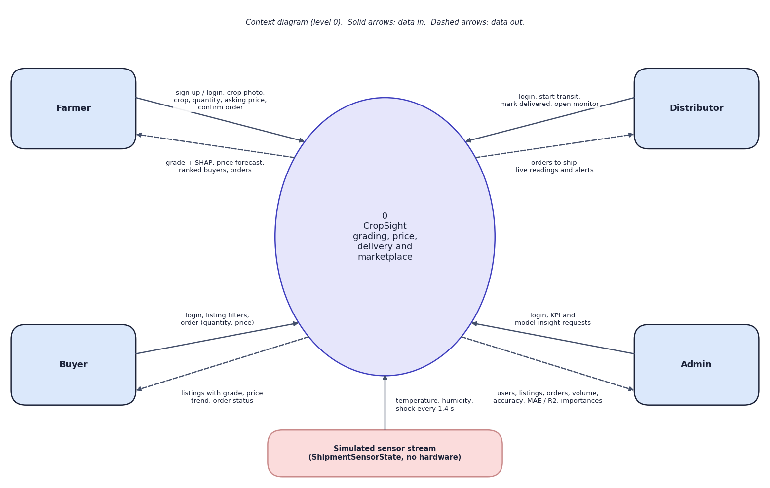
Fig. 3: Data-flow diagram, level 0 (context)
At the highest level CropSight is one process with five external entities. The farmer sends sign-up or login details, the crop photo, crop type, quantity, asking price and order confirmations, and receives the grade with its SHAP explanation, the price forecast, the ranked buyers and the orders. The buyer sends filters and orders and receives listings with grade, price trend and order status. The distributor sends login, start-transit and delivered actions and receives orders to ship and the live readings and alerts. The admin sends login and KPI or model-insight requests and receives user, listing and order totals, gross volume, and each model's accuracy or R2 and feature importances. The simulated sensor stream (ShipmentSensorState) supplies a temperature, humidity and shock reading every 1.4 seconds.

4 Data-Flow Diagram: Level 1
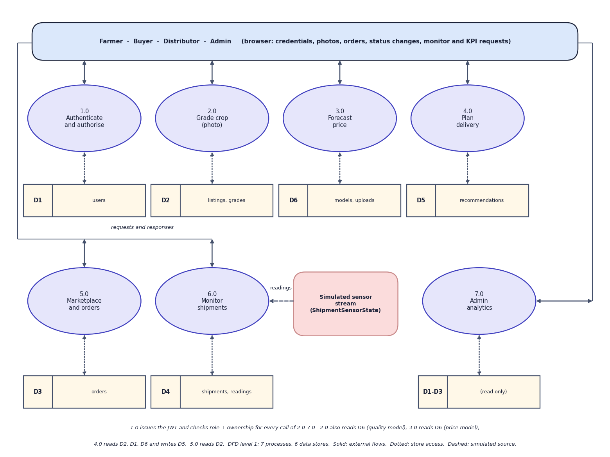
Fig. 4: Data-flow diagram, level 1
Level 1 splits CropSight into seven processes: authenticate and authorise (1.0), grade crop from a photo (2.0), forecast price (3.0), plan delivery (4.0), marketplace and orders (5.0), monitor shipments (6.0) and admin analytics (7.0). Six data stores hold the users (D1), the listings and grades (D2), the orders (D3), the shipments and sensor readings (D4), the stored delivery recommendations (D5) and the model files with the uploaded photos (D6). Process 1.0 issues the token and checks role and ownership for every call to processes 2.0 to 7.0. Process 2.0 reads the quality model from D6 and writes D2; 3.0 reads the price model from D6; 4.0 reads D2, the buyers in D1 and the towns, and writes D5; 5.0 reads D2 and writes D3 and the listing status; 6.0 receives readings from the simulated source and writes D4; 7.0 reads D1 to D3 and the two model files. Admin analytics is read-only.

5 Data-Flow Diagram: Level 2
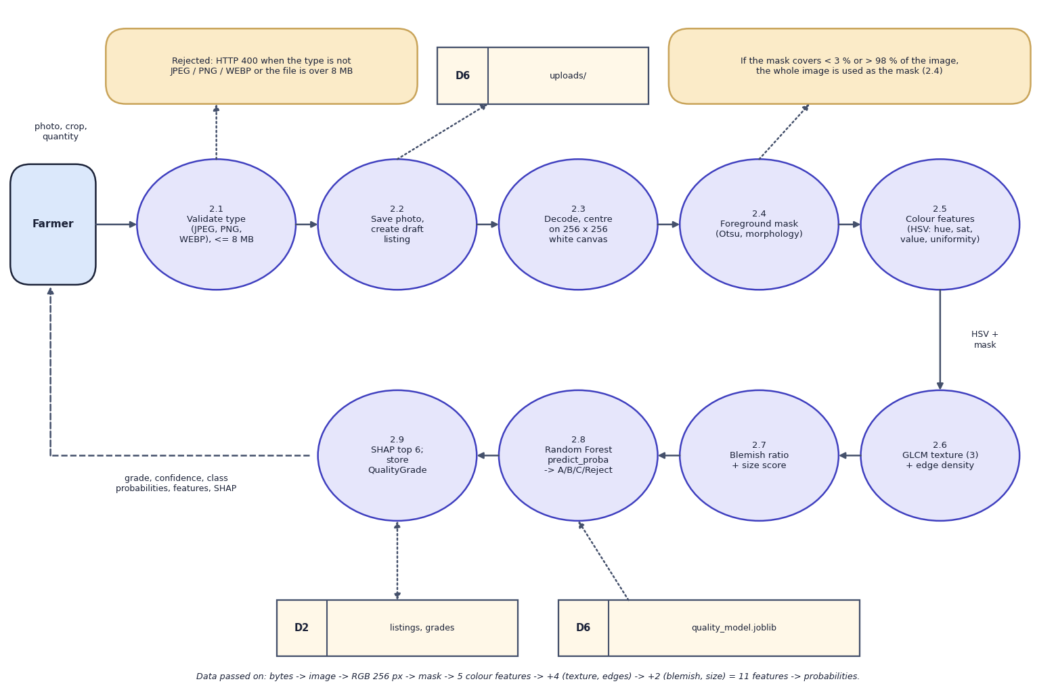
Fig. 5: Data-flow diagram, level 2: Grade crop (process 2.0)
Process 2.0 is expanded into nine steps that follow the code of upload_crop() and grade_image(). The type (JPEG, PNG or WEBP) and the size (8 MB at most) are validated first (2.1); a failure returns HTTP 400. The photo is saved under a random file name and a draft listing is created (2.2). The image is decoded and centred on a 256 x 256 white canvas (2.3). A foreground mask is made by Otsu thresholding on saturation, removal of bright low-saturation background and morphological opening and closing; if the mask covers less than 3 % or more than 98 % of the image, the whole image is used instead (2.4). Colour features are computed in HSV space: circular mean hue, mean saturation, mean value, saturation spread and colour uniformity (2.5). Three GLCM texture statistics and the edge density follow (2.6), then the blemish ratio and the size score (2.7). The 11 features go to the Random Forest, which returns class probabilities; the grade is the most probable class (2.8). SHAP gives the six strongest contributions and the result is stored as a QualityGrade row and returned (2.9).

6 Use-Case Diagram
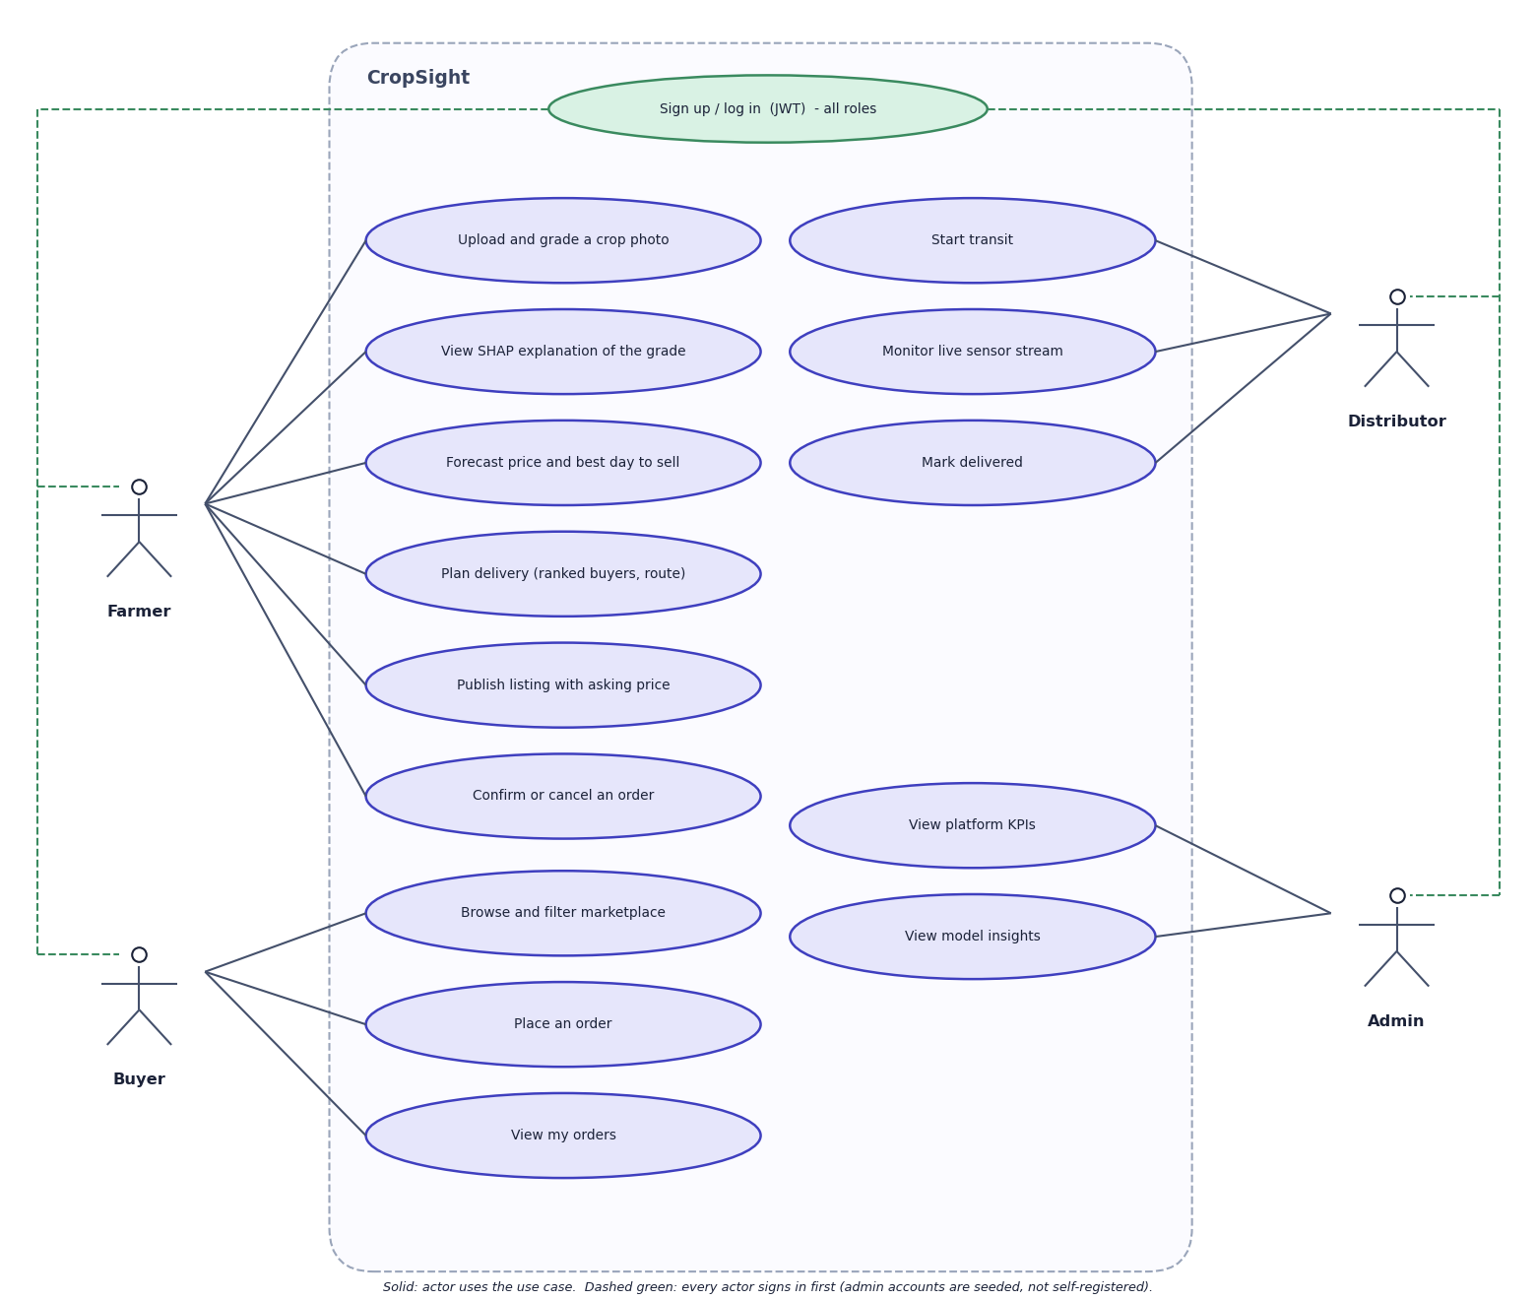
Fig. 6: Use-case diagram
Every actor first signs up or logs in. The farmer can upload and grade a crop photo, view the SHAP explanation of the grade, forecast the price and best day to sell, plan delivery, publish a listing with an asking price, and confirm or cancel an order. The buyer can browse and filter the marketplace, place an order and view their orders. The distributor can start transit, monitor the live sensor stream and mark an order delivered. The admin can view platform KPIs and the model insights. In the code the admin may also confirm, cancel or deliver any order; the diagram shows the use cases each role performs in normal operation. Admin accounts are seeded, not self-registered.

7 Sequence Diagram
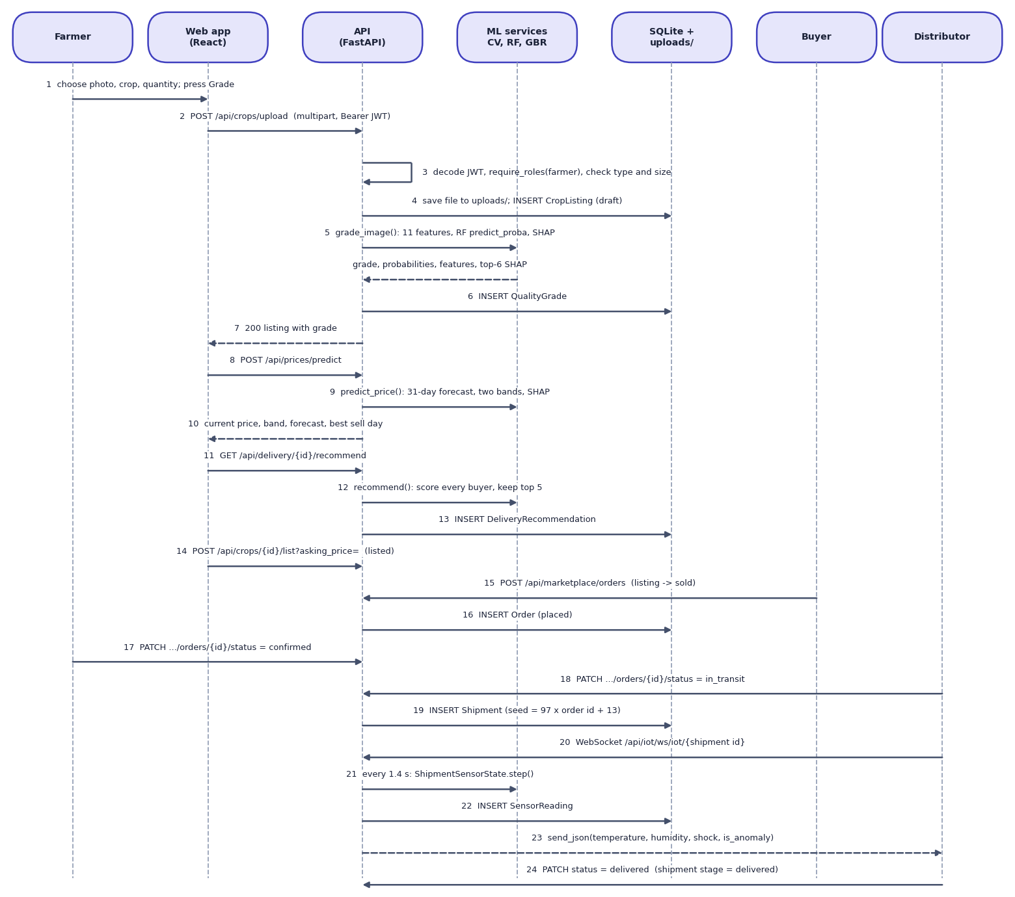
Fig. 7: Sequence diagram: from photo upload to delivery
The sequence shows the main flow in 24 steps across seven participants. The farmer chooses a photo and presses Grade; the web app posts the multipart request with the bearer token to /api/crops/upload. The API decodes the token, applies require_roles("farmer") and checks type and size (3), saves the file and inserts a draft CropListing (4), calls grade_image() on the machine-learning services (5), inserts the QualityGrade (6) and returns the listing (7). The web app then calls /api/prices/predict (8 to 10) and /api/delivery/{id}/recommend (11 to 13), after which the farmer publishes the listing (14). The buyer posts an order, which inserts an Order in the placed state and marks the listing sold (15, 16). The farmer confirms (17); the distributor starts transit, which inserts a Shipment whose seed is 97 times the order id plus 13 (18, 19) and opens the WebSocket (20); every 1.4 seconds the simulator produces a reading that is stored and pushed to the browser (21 to 23). Finally the distributor marks the order delivered and the shipment stage becomes delivered (24).

8 Entity-Relationship Diagram
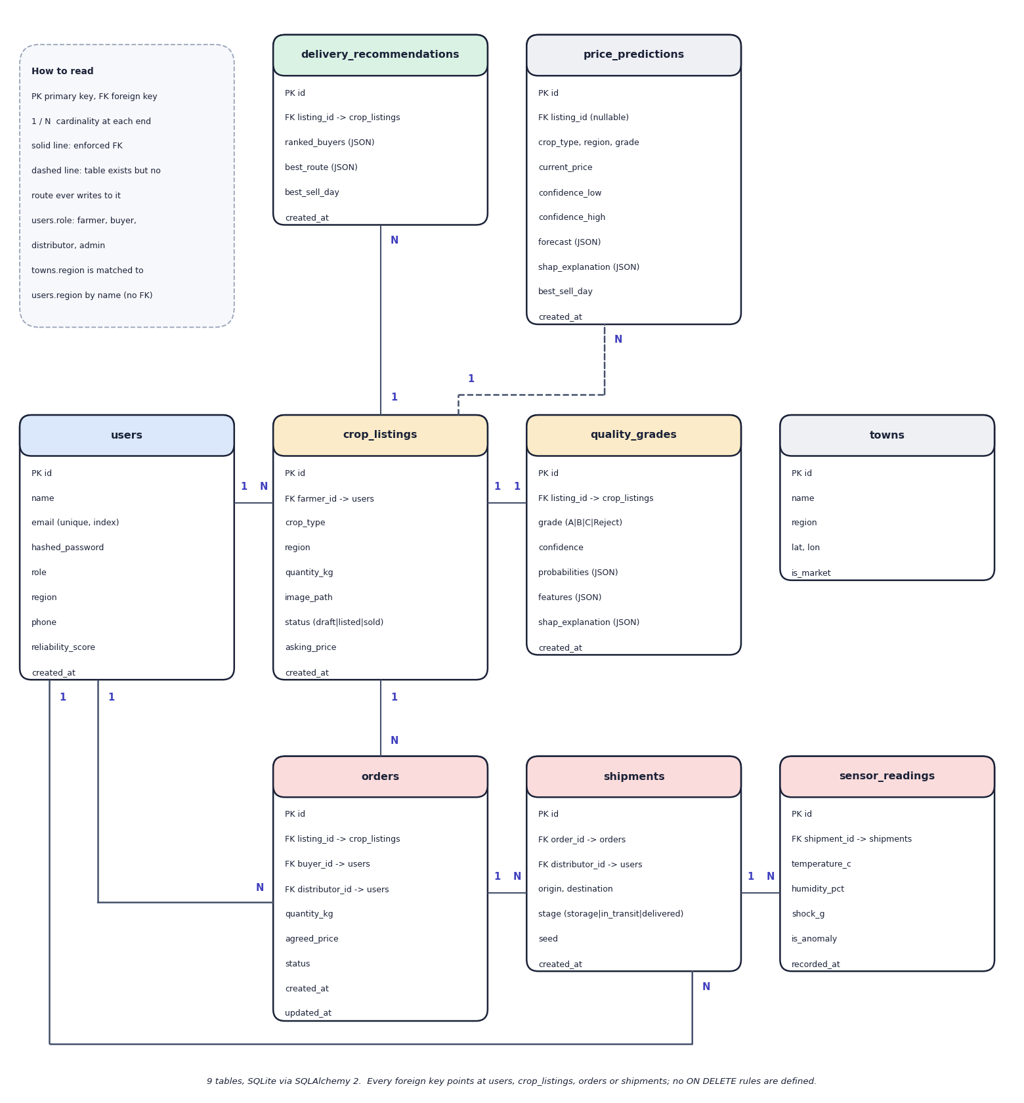
Fig. 8: Entity-relationship diagram (9 tables)
Nine tables are created by SQLAlchemy in SQLite. A user (farmer) owns many crop listings; each listing has at most one quality grade, many delivery recommendations and, once sold, orders. An order refers to a listing and to a buyer, and optionally to the distributor who took it; a shipment refers to an order and a distributor, and a shipment has many sensor readings. The towns table holds the eight market towns with coordinates and is joined to users and listings by region name only, not by a foreign key. The price_predictions table is drawn dashed: the model and table exist, but no route writes to it. No foreign key has an ON DELETE rule.

9 UML Class Diagram
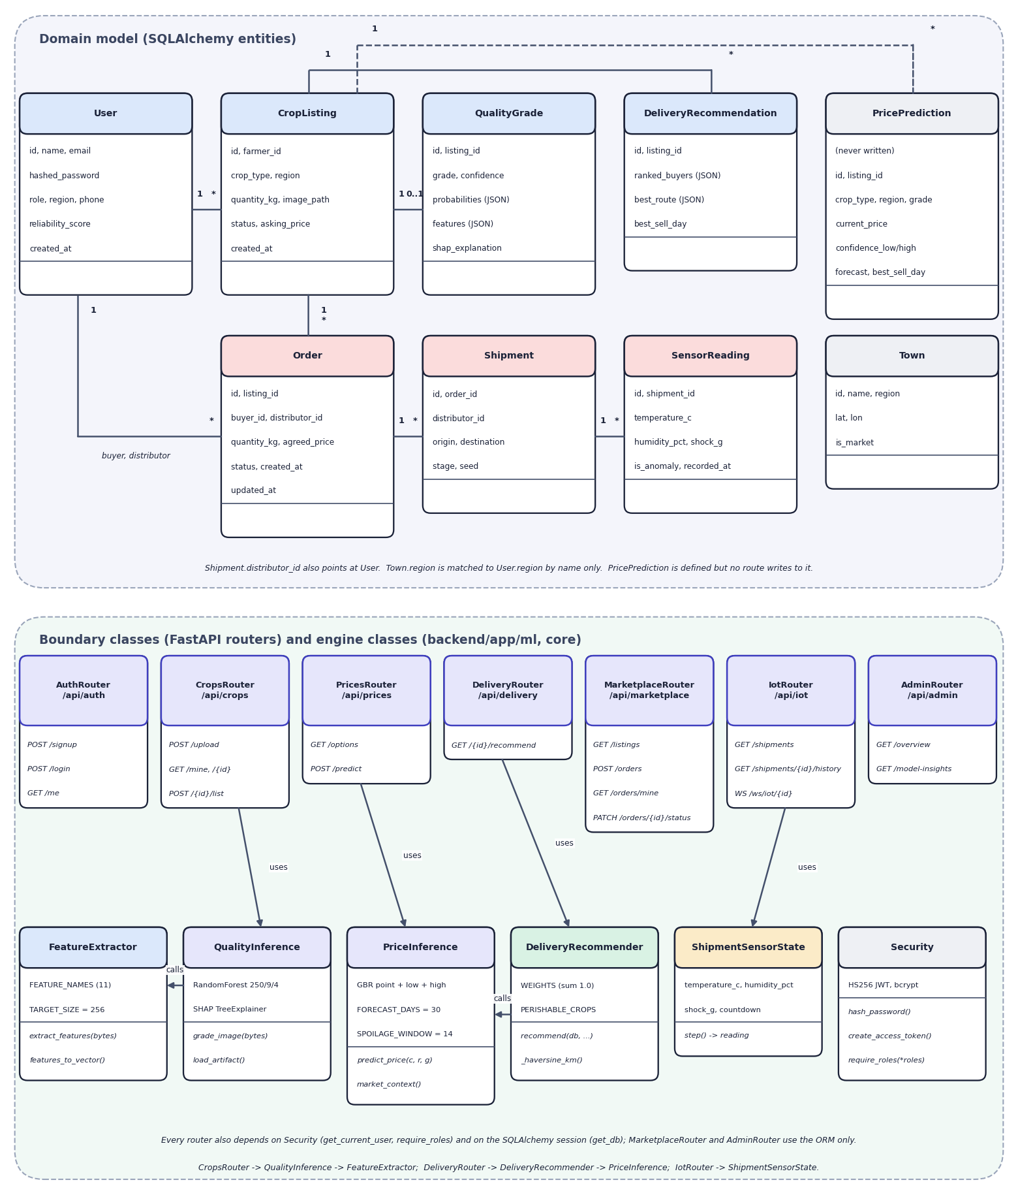
Fig. 9: UML class diagram
The upper part shows the domain model, the nine SQLAlchemy entities with their main attributes and associations (a user has many listings; a listing has one quality grade, many orders and many recommendations; an order has one shipment; a shipment has many sensor readings; Order points to users twice, as buyer and as distributor). PricePrediction is marked as never written and Town is matched to users by region name only. The lower part shows the boundary classes, the seven FastAPI routers with their routes, and the engine classes behind them: FeatureExtractor with the 11 feature names and the 256-pixel target size; QualityInference with the Random Forest (250 trees, depth 9) and the SHAP explainer; PriceInference with the point and two quantile models, the 30-day horizon and the 14-day spoilage window; DeliveryRecommender with the five weights and the perishable-crop set; ShipmentSensorState; and Security. Arrows show which router uses which engine.

10 Flowchart of the Core Algorithm
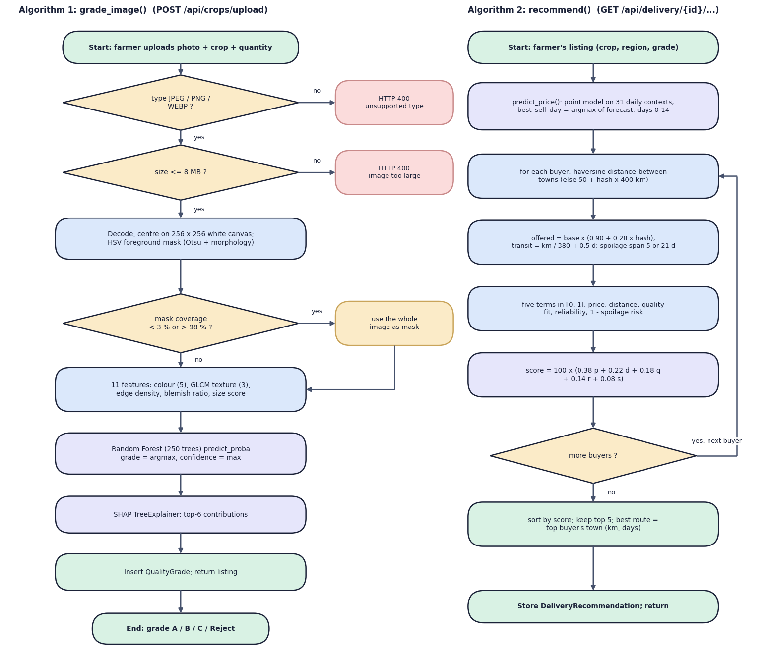
Fig. 10: Flowcharts of the two core algorithms: grade_image() and recommend()
The left flowchart is the grading algorithm. Two decisions guard the input: an unsupported type or a file over 8 MB is rejected with HTTP 400. The image is decoded, centred and masked; the third decision handles a failed mask by using the whole image. Eleven features are computed, the Random Forest returns probabilities, the grade is the most probable class, SHAP gives the top six contributions, and the QualityGrade row is stored.
The right flowchart is the delivery recommender. It first calls predict_price() to obtain the reference price and the best sell day (argmax of the forecast over days 0 to 14). For every buyer it computes the haversine distance between the two towns (or 50 plus a hash times 400 km when a town is missing), a simulated offered price of the base price times 0.90 to 1.18, the transit time as distance over 380 km per day plus half a day, and the spoilage risk against a 5-day span for perishable crops (21 days otherwise). The five terms, each in [0, 1], are combined as 100 x (0.38 price + 0.22 distance + 0.18 quality fit + 0.14 reliability + 0.08 (1 - spoilage risk)). The loop repeats while buyers remain; the list is sorted, the top five are kept, the best route is the top buyer's town, and the recommendation is stored.

